**Homework #11 Part 2**

**Team 2:**

**Julian Carvajal Rico**

**Roberto Enriquez Vargas**

The comparison between solving unsymmetric and symmetric systems of linear equations using the MKL LAPACK library from Cython gives some important conclusions regarding computational efficiency. Specifically, the results indicate that using the symmetric properties of a matrix significantly reduces computation time. In the case, where a 10,000 x 10,000 matrix is solved, the symmetric solver outperforms the unsymmetric one, completing the task in almost half the time (0.481 seconds compared to 0.858 seconds). This efficiency gain is attributed to specialized algorithms that can take advantage of the symmetry in the matrix, leading to a reduction in algorithmic complexity which leads to faster computation. The results show the importance of algorithm selection in scientific computing. For large-scale problems or applications where performance is critical, such as real-time simulations or large data analysis, the choice of a symmetric solver when applicable can lead to significant improvements in execution times. Furthermore, the use of Cython and the MKL library demonstrates the effective bypassing of Python's Numpy’s system solvers, allowing for optimized, high-speed computations. Ultimately, this example emphasizes the practical benefits of understanding and utilizing mathematical properties of problems within optimized libraries, which can be crucial for efficiency in computational tasks.

**Table 1. HW11 Results**

|  |  |  |
| --- | --- | --- |
| Method | Time (s) | Speedup |
| Unsymmetric System | 0.857590 | 0 |
| Symmetric System | 0.481157 | 1.782349628 |

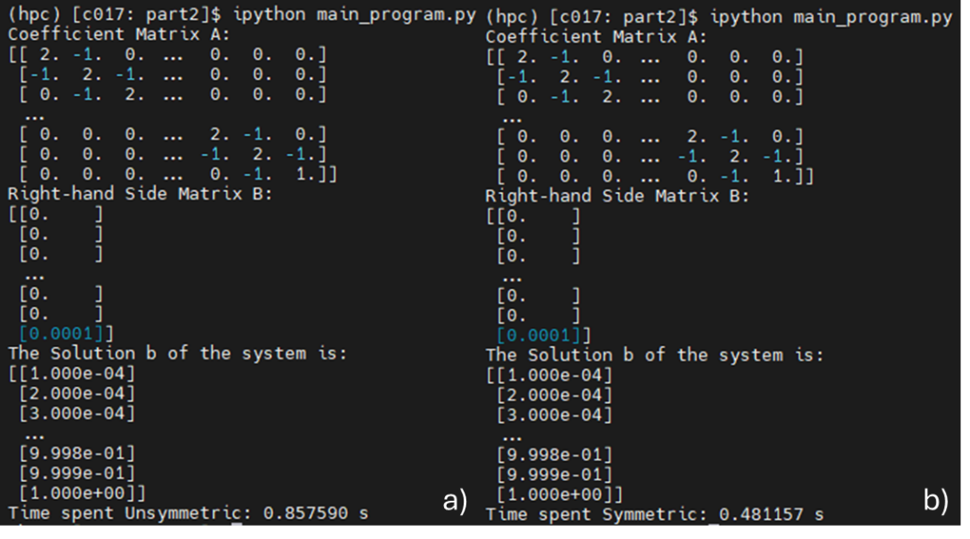

**Figure 1. a) Unsymmetric System. b) Symmetric System**